**Upload Instructions for QTI Question Banks**

Demetrios Pagonis

demetriospagonis@weber.edu

1. Navigate to the “Settings” page of your Canvas course

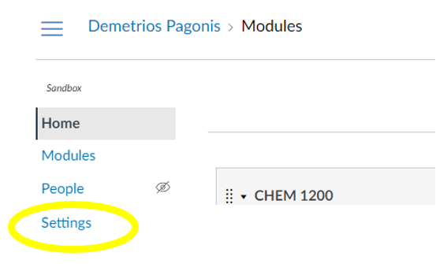

1. Select “Import Course Content” from the left-side menu

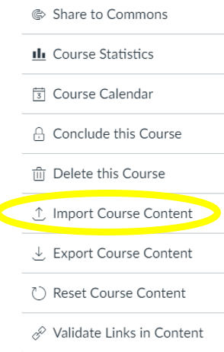

1. Select “QTI .zip file” as the Content Type:

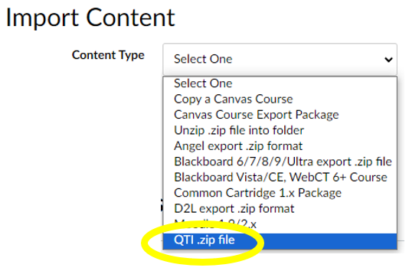

1. Select the file to upload from your computer as the “Source”

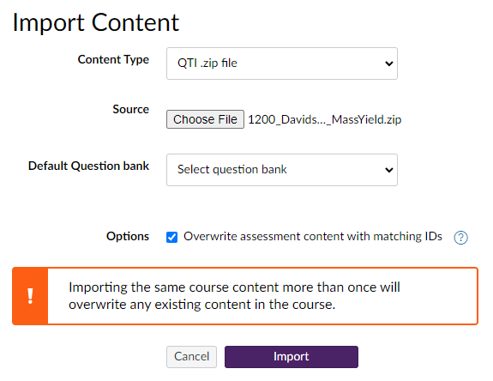

1. Leave the “Default Question bank” option unchanged
2. Select the “Overwrite assessment content with matching IDs” option.
   1. *If you leave this unchecked you will end up with multiple banks with the same name*
3. Press “Import”
4. After a few minutes of processing the question bank will be available in that course